Stecci Mapping
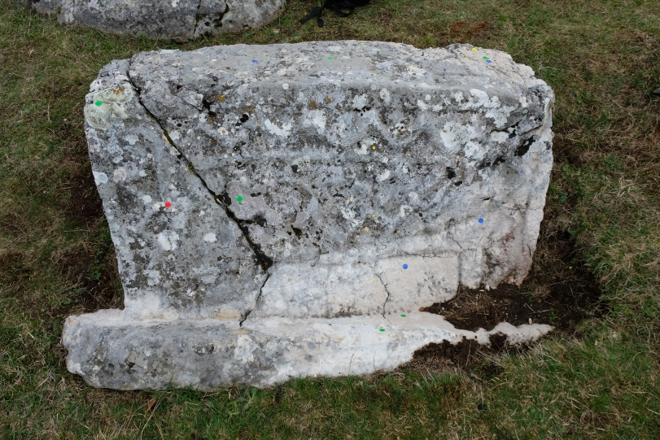

AI-based mapping algorithm in development (Python) to analyzes a photo of a stecci (carved tombstone/rock) to find the rock, detect cracks, and classify surface features like biological growth.
Overview
Four AI-Machine Learning models/algorithm families are chained together, each handling what it's best at:
Stage | Model | Role
1 | Grounding DINO | Find where the rock roughly is (a box)
2 | SAM (SamPredictor) | Turn that box into a pixel-precise rock mask
3 | Classic CV (black-hat or Frangi filter) | Find cracks on the isolated rock
4 | SAM (SamAutomaticMaskGenerator) + CLIP | Break the rock into sub-regions and label what each one is (e.g. Biological Colonization)

Algorithmic Pipeline
- Step — Grounding DINO: locate the rock
Model: IDEA-Research/grounding-dino-base, loaded via Hugging Face transformers (AutoModelForZeroShotObjectDetection).
What it is: Grounding DINO is an open-vocabulary object detector — instead of being trained on a fixed list of classes (like "car", "dog"), you give it a free-text prompt (here, "rock") and it returns bounding boxes for anything in the image matching that description, with a confidence score. This makes it useful when there's no pretrained detector for your exact object class.
What happens: The image and the prompt "rock." are run through the model. It may return multiple candidate boxes (e.g. several rocks/stones in frame); the code picks the single box whose center is closest to the image center, since the stecci is assumed to be the central subject. The result is one bounding box (x1, y1, x2, y2).
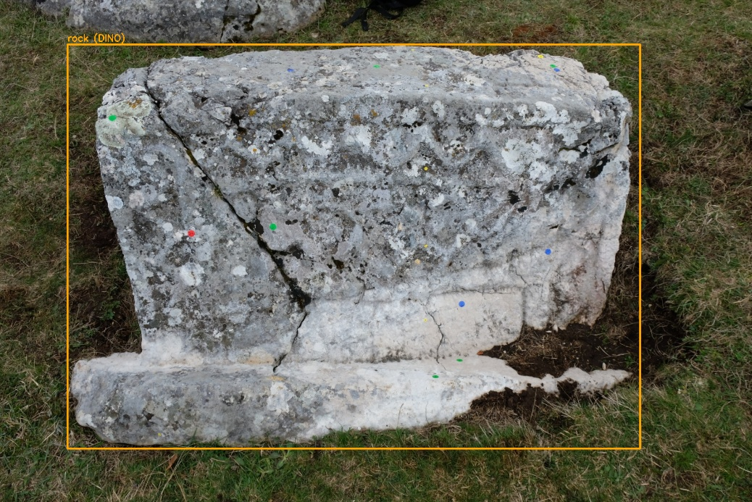

- Step — SAM: isolate the rock precisely
Model: SAM (Segment Anything Model), vit_h checkpoint, used via SamPredictor.
What it is: SAM is Meta's prompt-able segmentation model — given an image plus a "prompt" (a point, a box, or a mask), it outputs a precise pixel mask of the object indicated by that prompt. It generalizes to arbitrary objects it's never seen labeled before.
What happens: The Grounding DINO box from Step 1 is fed into SamPredictor as the prompt. SAM returns one high-quality binary mask that hugs the actual silhouette of the rock — much tighter than the rectangular box. Everything outside that mask is blacked out, producing an "isolated rock" image and a mask PNG. This isolated image becomes the input to all subsequent steps, so background clutter never confuses later stages.
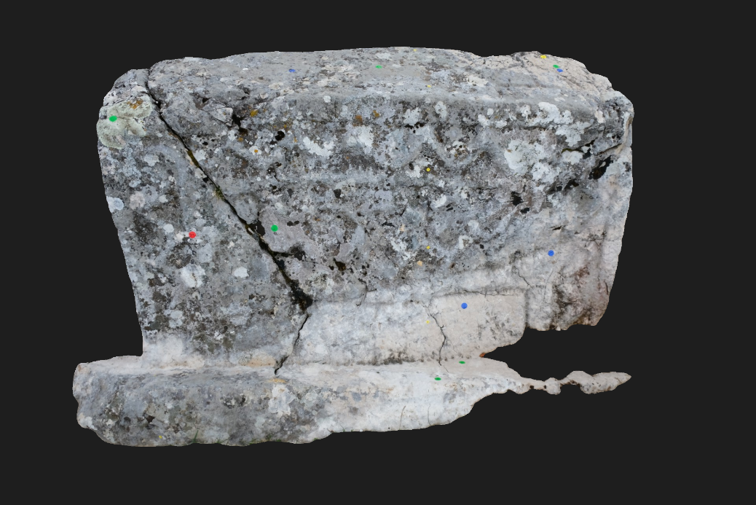

- Step — Classic CV: crack detection
No ML model — two selectable classical algorithms (CRACK_METHOD):
- tiled_blackhat: A morphological black-hat transform (highlights dark thin structures on a lighter background) applied per-tile with local Otsu thresholding, so it adapts to lighting that varies across a large rock face.
- frangi_multiscale: A multi-scale Frangi ridge/vesselness filter — originally designed to detect blood vessels in medical images — repurposed here to detect thin, elongated ridge-like structures (cracks) at multiple scales (FRANGI_SIGMAS). Candidates are then filtered by elongation (aspect ratio), length, and area to reject noise/texture that isn't crack-shaped.

The results are superposed with the SAM rock mask so no crack pixels bleed outside the rock's silhouette. Cracks are also color-coded by estimated width (hairline / medium / wide) using skimage.measure region properties.
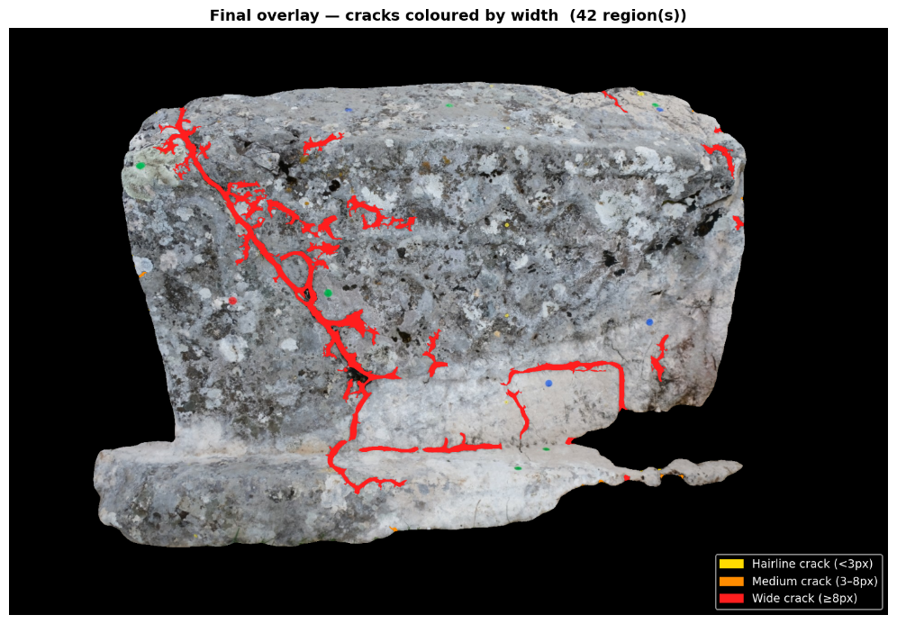

- Step — SAM (auto-segmentation) + CLIP (Classify)
  - SAM (auto-segment everything)
Model: SAM again, but via SamAutomaticMaskGenerator instead of SamPredictor.
What it is: Instead of being prompted with one box, this mode seeds SAM with a dense grid of points (SAM_POINTS_PER_SIDE) across the image and lets it propose many candidate object masks automatically, then filters them by predicted IoU and stability score.
What happens: It's run on the rock crop (with everything outside the rock blacked out), automatically breaking the rock surface into many smaller segments (patches, regions, texture areas). Masks that mostly fall outside the true rock mask are discarded as border artifacts.
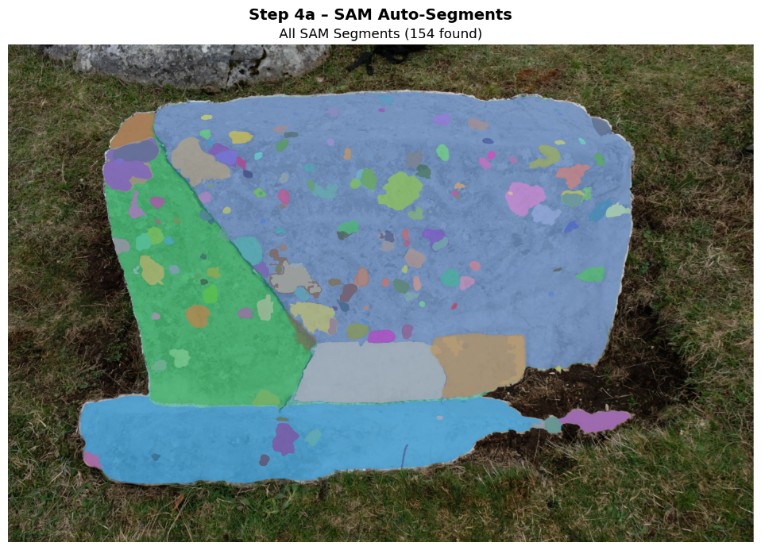

  - CLIP (classify each segment)
Model: CLIP (ViT-B-32, OpenAI weights), via open_clip.
What it is: CLIP is a model jointly trained on images and text so that matching image/text pairs land close together in a shared embedding space. This lets you classify an image against arbitrary text labels ("zero-shot") without training a classifier — just embed candidate text prompts and pick whichever one is closest to the image embedding.
What happens: For each SAM segment smaller than the mean segment size, the code crops tightly around it (masking out everything else to grey), embeds the crop with CLIP's image encoder, and compares it against the embeddings of category text prompts (currently just "biological colonization", e.g. "lichen on rock", "algae on rock"). The best-matching category is assigned if confidence clears MIN_CONFIDENCE; otherwise, it falls back to a default category.
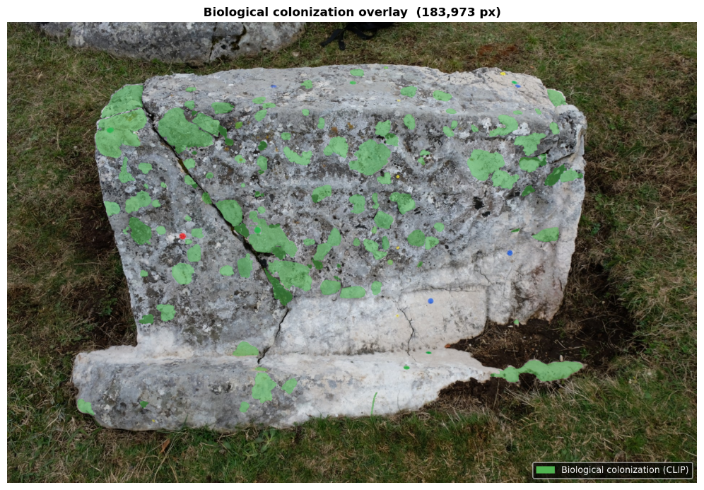

- Step — Interactive viewer (Review tool)
A matplotlib window with sliders/radio buttons to toggle opacity of each layer (SAM segments, biological-colonization overlay, crack overlay, segment borders) over either the original or isolated-rock background — purely a review/QA tool, no models involved here.

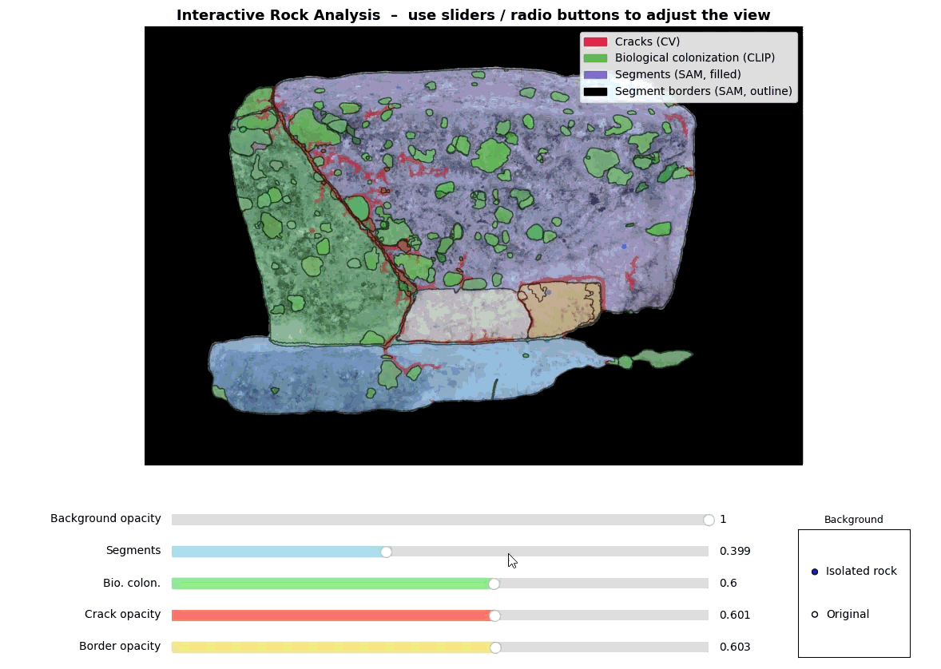

Summary of the logic
Grounding DINO answers "where is the rock" → SAM turns that into a precise mask → classical CV finds cracks on that clean surface → SAM again breaks the surface into candidate regions → CLIP labels each region what it is (currently just biological growth detection, but it could also detect pitting, white encrustation, etc.).

